Game’s Complete

# Game 17: The IF bloc

# Game 18: The keys on 2 stairs

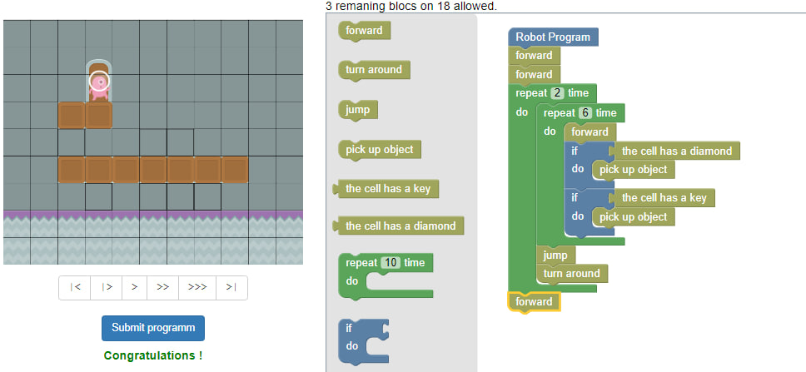

# Game 19: The square of diamonds V2

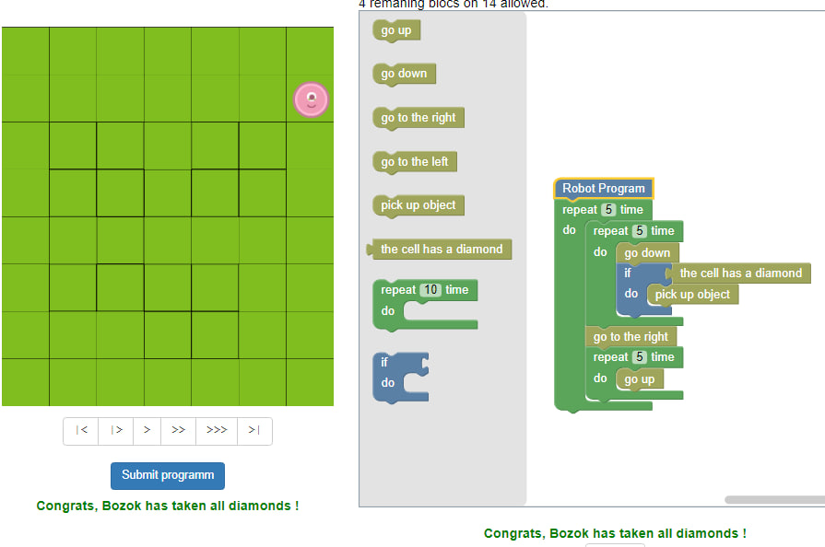

# Game 20: The 4 stairs of diamonds

# Game 21: The locker of anywhere !

